**Australian Islamic College 2020**

**ATAR Chemistry Units 3 and 4**

**Task 11A (Weighting: 2%)**

**Polymers Test**

Test Time: 35 minutes

Please do not turn this page until instructed to do so.

|  |  |
| --- | --- |
| **First Name** | **Surname** |
|  |  |

|  |
| --- |
| **Teacher** |
|  |

|  |  |
| --- | --- |
| **Mark / 34** | **Percentage** |
|  |  |

Equipment allowed: Pens, pencils, erasers, whiteout, correction tape, rulers and non-programmable calculators permitted by the Schools Curriculum and Standards Authority.

**Special conditions**:

2 marks will be deducted for failing to write your full name on this test paper.

**Teacher help**: Your teacher can only help you during your test in one situation.

If you believe there is a mistake in a question show your teacher and your teacher will tell you if there is a mistake in the question and if appropriate, how to fix that mistake.

**Spelling of Science words** must be correct. Unless otherwise indicated, science words with more than one letter wrong (wrong letter and/or wrong place) will be marked wrong. The spelling of IUPAC names must be exactly correct.

Unless otherwise stated, **equations** must be written balanced and with correct state symbols or they will be marked wrong.

Questions must be answered in this booklet.

Total marks: 34

**PART ONE: MULTIPLE CHOICE QUESTIONS (14 MARKS)**

**Circle the correct answers on the questions.**

1. Glucose molecules are joined in the human liver in a series of condensation reactions to form a condensation polymer called glycogen. Each time two molecules of glucose are joined a molecule of water is lost.

200 molecules of glucose, C6H12O6, polymerise to form glycogen. What is the molar mass, in g mol-1, of the resulting polymer?

* 1. 32450 g mol-1
  2. 32430 g mol-1
  3. 32460 g mol-1
  4. 36030 g mol-1

1. Ultra high molecular weight polyethylene (UHMWPE), which has a molecular weight in excess of 3,000,000 g mol-1, is used to make bulletproof vests. In contrast, low density polyethylene (LDPE) is used to make thin plastic bags for bread and fruit. What explains why UHMWPE is so much stronger than LDPE?
   1. UHMWPE has chlorine atoms that allow for dipole-dipole forces. These are not found in LDPE.
   2. UHMWPE has nitrogen atoms that allow for hydrogen bonding. Hydrogen bonding is not found in LDPE.
   3. UHMWPE has ester linkages. LDPE does not have these.
   4. UHMWPE has much longer polymer chains than LDPE.

Questions 3 and 4 refer to the polymer shown below.

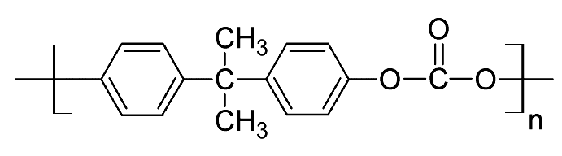

1. What type of polymer is this?
   1. Polyester
   2. Polyvinyl
   3. Polyamide
   4. Addition
2. Which intermolecular forces are present between molecules of this polymer?
   1. Dispersion forces, dipole-dipole forces and hydrogen bonds.
   2. Dispersion forces and dipole-dipole forces.
   3. Dispersion forces and hydrogen bonds.
   4. Dispersion forces, dipole-dipole forces, ion-dipole forces and hydrogen bonds.
3. Shown below are two polymers.

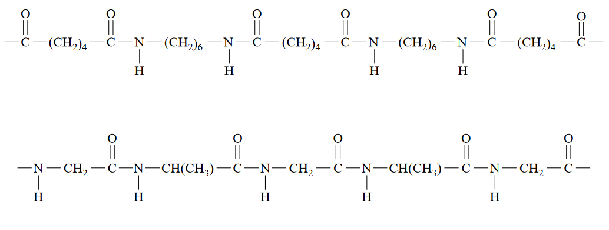

Which statement is true about these polymers?

* 1. Both polymers are polyesters.
  2. Both polymers are addition polymers.
  3. Both polymers are copolymers.
  4. The strongest intermolecular forces in both polymers are dipole-dipole forces.

1. Copolymers are obtained when two or more different monomers are allowed to polymerise together. Part of a copolymer chain is shown below.

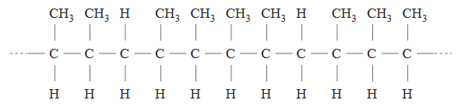

The two alkenes that could react together to form this polymer are

* 1. Propene and but-1-ene.
  2. Propene and but-2-ene.
  3. But-1-ene and but-2-ene.
  4. Pent-2-ene and but-2-ene.

1. Cuts and wounds are often stitched using a biodegradable polymer with the formula

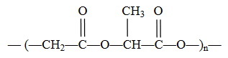

It is made from a condensation polymerisation reaction between lactic acid (HOCH(CH3)COOH) and glycolic acid.

The formula of glycolic acid is

* 1. HOCH2COOH
  2. HOCH2CH2OH
  3. HOOCCH2COOH
  4. HOOCCH2CH2OH

1. The following structure represents the repeating unit of a polymer used in the manufacture of contact lenses.

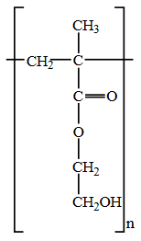

Which one of the following is a correct statement about the monomers that react to form this polymer?

* 1. Each monomer contains a double bond between carbon atoms which allows addition polymerisation to take place.
  2. Two different monomers react to form the polymer, one with carboxyl groups and the other with hydroxy groups.
  3. The total mass of the monomers is greater than the mass of the polymer formed because water is eliminated in the polymerisation reaction.
  4. Each monomer contains both a carboxyl and a hydroxy group which allows condensation polymerisation to take place, forming a polyester.

1. A short section of a polymer molecule is shown below.

-CH2CF2CF2CH2CF2CH2CH2CF2CH2-

This polymer could have been formed from

* 1. CF2CH2 only.
  2. CF2CF2 and CH2CH2.
  3. CF2CF2 and CH2CHCF3.
  4. CH3CHCF2 and CF3CHCF2.

1. The molecule HOCH2CH2CH2COOH (molar mass = 104 g mol-1) forms a polymer in which the average polymer molecule contains 1000 monomer units. The approximate molar mass of the polymer, in g mol-1, is
   1. 68 000
   2. 86 000
   3. 95 000
   4. 104 000
2. A representation of a section of a polymer chain, that has been produced from two different monomers, is given below.

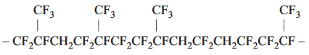

The two monomers are

* 1. CH2=CF2 and CF2=CFCF3
  2. CF2=CF2 and CF2=CFCF3
  3. CH2=CF2 and CH2=CFCF3
  4. CF2=CF2 and CH2=CFCF3

1. A short section of a polymer is shown below.

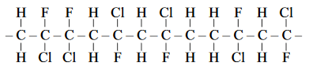

What is the name of the monomer that has been polymerised to make this polymer?

* 1. 1-chloro-2-fluoroethene
  2. 1-chloro-2-fluoropropene
  3. 1-chloro-1-fluoroethene
  4. 1-fluoro-1-chloroethene

1. Consider the addition polymerisation of CH3CH=CHCH3.The structure of the resulting polymer would be

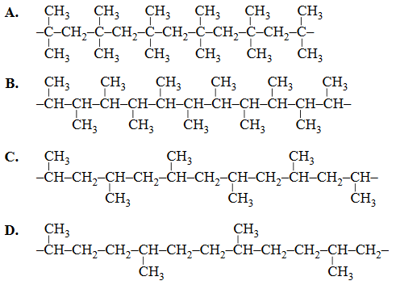

1. The IUPAC name of the polymer formed in question 13 above is
   1. Polybutene
   2. Polybut-2-ene
   3. Poly (butane)
   4. Poly (but-2-ene)

**PART TWO: SHORT ANSWER QUESTIONS (20 MARKS)**

1. Draw, using appropriate bracket notation, the polymer that would form from this monomer. Show all atoms and all bonds.

(2 marks)

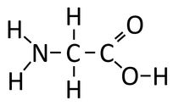

1. Ethane-1,2-diamine (NH2CH2CH2NH2) forms a condensation copolymer with butanedioic acid (HOOCCH2CH2COOH).
   1. Use appropriate square bracket notation to draw the structure of the repeating unit of the copolymer that would be formed. Show all atoms and all bonds.

(3 marks)

* 1. Is the polymer formed above a polyester, a polyamide or an addition polymer?

(1 mark)

1. Cellulose is the plant polymer referred to as ‘fibre’ when it forms part of the human diet. A short section of cellulose is shown below.

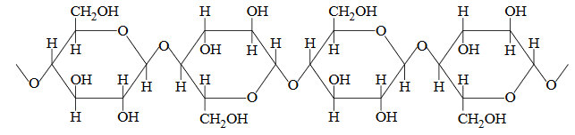

* 1. When two monomers join during cellulose formation, a molecule of water is lost. Is cellulose an addition polymer, a polyamide, a polyester or none of these? Explain how you know by referring to structure/s shown in the diagram above.

(4 marks)

* 1. Draw one of the monomers that are polymerised to make cellulose.

(1 mark)

1. Perspex (polymethyl methacrylate) is a clear, colourless polymer used for optical applications. The structural formula of the only monomer used in the synthesis of perspex, methyl methacrylate, is shown below.

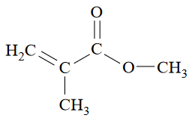

Draw a section of the polymer showing exactly two units of the monomer.

(3 marks)

1. Dacron is the trade name for a common polyester used in making clothes and water bottles. Part of its structural formula is given below:

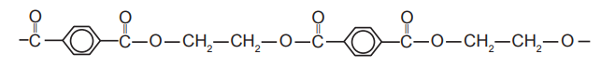

* 1. Draw the structural formula for the two monomers that react to form this polymer.

(2 marks)

Monomer 1

Monomer 2

* 1. Predict and explain the effect on the polyester’s rigidity and melting point as the polymer chains increase in length.

(4 marks)